TERRANEXT GLOBAL VENTURES
AI Intelligence Platform
API & AI Workflow Guide
Document 5 of 8 · Version 1.0
August 2, 2026
CONFIDENTIAL — Prepared exclusively for TerraNext Global Ventures

Document Control
Document Title | AI Intelligence Platform — API & AI Workflow Guide
System | TerraNext Business OS
Classification | Confidential — Client Delivery
Prepared For | TerraNext Global Ventures
Prepared By | Engineering Documentation Team
Status | Final
Related Documents | Technical Architecture Guide; Developer Guide; Known Limitations & Engineering Notes

Version History
Version | Date | Author | Description of Changes
1.0 | 2026-08-02 | Engineering Documentation Team | Initial release — converted from the Markdown source of truth for client handover.

Table of Contents
Right-click this table and choose "Update Field" → "Update entire table" to populate page numbers after opening this document in Word.

There is no public REST or callable HTTPS API for this module — every entry point below is a Next.js Server Action (invoked from React, not fetchable as a URL) except the one Cloud Function, which is a Firestore trigger, not an HTTP endpoint. Provider trade-offs, cost/latency implications, and reliability considerations are consolidated in 04 — Known Limitations & Engineering Notes §4; this document covers the underlying mechanics only.

1. Provider selection rationale
The module is built against a provider-agnostic interface (SpeechProvider/SummaryProvider, functions/src/ai/providers/types.ts) rather than being hard-wired to one vendor, and ships with two real implementations plus a zero-cost mock:
- OpenAI — reference speech provider. Whisper (whisper-1) performs speech-to-text; a separate GPT chat-completion call performs speaker classification, since Whisper itself has no diarization capability.
- Gemini — alternative provider. Supports audio understanding and structured JSON generation in a single multimodal call (transcription + speaker labelling together).
- Mock — the default, so the full pipeline can be built, tested, and demonstrated with zero API keys and zero cost before a real provider is chosen.
Both real providers are called via raw fetch against the vendors' REST APIs — no vendor SDK is installed as a dependency for this module.

2. Server actions — complete contract reference
All actions live under src/features/ai-intelligence/actions/, are declared 'use server', and return Promise<Result<T>> ({ok: true, data: T} | {ok: false, error: {code, message, fields?}}). None are reachable as HTTP routes — they are called directly from React Server/Client Components via Next.js's Server Actions transport.

createSession
Permission | aiIntelligence:create
Input | { title: string (3-200 chars); batchId?: string (≤120); programmeId?: string (≤120); deviceLabel?: string (≤200) }
Extra validation | batchId/programmeId, if provided, must reference an existing document (batchExists/programmeExists)
Output | { sessionId: string }
Side effects | Creates aiSessions/{id} with status: 'draft', trainerUid = caller; 1 audit log entry (create, ai_session)

requestChunkUploadTicket
Permission | aiIntelligence:create + caller must be the session's trainerUid
Input | { sessionId; chunkIndex: 0-8; contentType: one of ALLOWED_AUDIO_CONTENT_TYPES; sizeBytes: 1-14,680,064; startOffsetSec: 0-5400 }
State preconditions | chunk 0 requires session status in {draft, recording}; any other chunk requires status === 'recording'
Output | { sessionId, chunkIndex, uploadUrl (v4 signed PUT URL, 30-min TTL), contentType }
Side effects | Upserts chunks/{chunkIndex} (status: 'uploading'); if this is chunk 0 of a still-draft session, also flips session status to 'recording'. No audit entry (upload plumbing).

confirmChunkUpload
Permission | aiIntelligence:create + ownership
Input | { sessionId; chunkIndex: 0-8; durationSeconds: 1-630 }
State preconditions | session status === 'recording'; a chunk reservation must already exist
Output | { status: 'uploaded' } | { status: 'failed' } — a business-level success response can still carry `status: 'failed'`; callers must check the payload, not just `ok: true`
Side effects | Verifies the actual Storage object's size/content-type against the reservation (deleting the object on mismatch); marks the chunk uploaded or failed accordingly. No audit entry.
⚠ WARNING
confirmChunkUpload returning ok: true does not mean the chunk uploaded successfully — check data.status before proceeding. Any client or script calling this action directly (rather than through the existing recorder component) must handle the { status: 'failed' } branch explicitly, or it will silently treat a failed upload as a success.

finalizeSessionRecording
Permission | aiIntelligence:create + ownership
Input | { sessionId; totalChunks: 1-9; totalDurationSeconds: 1-5460 }
Extra validation | planSessionChunks(totalDurationSeconds).length must equal totalChunks (server-independent re-derivation); every chunk 0..totalChunks-1 must exist, be contiguous, and be status === 'uploaded'
Output | { jobId: string }
Side effects | One transaction: session → status: 'processing', totalChunks, durationSeconds, endedAt, processingJobId; creates aiProcessingJobs/{jobId} with stage: 'queued'. This write is what fires processAiSessionJob. 1 audit log entry (update, ai_session, status: recording→processing).

retryProcessingJob
Permission | aiIntelligence:update + (session owner OR aiIntelligence:configure)
Input | { jobId: string }
State preconditions | job stage === 'failed' (transactionally re-checked to guard concurrent double-clicks)
Output | { jobId: string }
Side effects | stage: 'failed' → 'queued', error: null, attempts += 1. Re-fires processAiSessionJob, which resumes from non-transcribed chunks. 1 audit log entry (update, ai_processing_job, stage: failed→queued).

deleteSession
Permission | aiIntelligence:delete (no ownership check)
Input | { sessionId: string }
Output | { sessionId: string }
Side effects | Sets deletedAt only — status, audio, transcript, and summary are untouched. 1 audit log entry (soft_delete, ai_session).

updateAiSettings
Permission | aiIntelligence:configure
Input | { autoClassifySpeakers: boolean; notifyTrainerOnCompletion: boolean; audioRetentionDays: 7-3650 }
Output | void
Side effects | Merge-writes aiIntelligenceSettings/config. Does not touch activeSpeechProvider/activeSummaryProvider — those are pipeline-stamped only. 1 audit log entry (update, ai_intelligence_settings).

3. Read query reference (queries.ts)
Function | Returns | Notes
listSessions(options?: { trainerUid?: string }) | AiSession[] | Accepts an owner filter; see 04 §1 — L2 for how it's actually used today
getSessionDetail(sessionId) | { session, transcript, summary } | See L2 for read-scoping detail
listProcessingJobs() | AiProcessingJob[] | All jobs, not filtered by owner
getDashboardStats() | AiDashboardStats | { todaysSessions, pendingProcessing, completedSessions, recordingHours }
getRecentAnalytics(days = 30) | AiAnalyticsDay[] | Fixed default window; ascending-sorted for chart rendering
getAiSettings() | AiIntelligenceSettings | Falls back to a hardcoded default object if the settings doc doesn't exist

4. AI provider workflow — how transcription and summarization actually work

4.1 Common contract
interface SpeechProvider {
readonly name: string;
transcribe(input: { audioBuffer: Buffer; contentType: string; sessionTitle: string })
: Promise<{ fullText: string; language: string; segments: TranscriptSegment[] }>;
}
interface SummaryProvider {
readonly name: string;
summarize(input: { transcriptText: string; sessionTitle: string })
: Promise<{ executiveSummary: string; keyLearningPoints: string[]; importantQuestions: string[]; actionItems: string[] }>;
}
interface TranscriptSegment {
speaker: 'trainer' | 'student' | 'unknown';
speakerLabel: string;
text: string;
startSec: number;
endSec: number;
}

getSpeechProvider()/getSummaryProvider() (factory.ts) select an implementation purely from environment configuration:
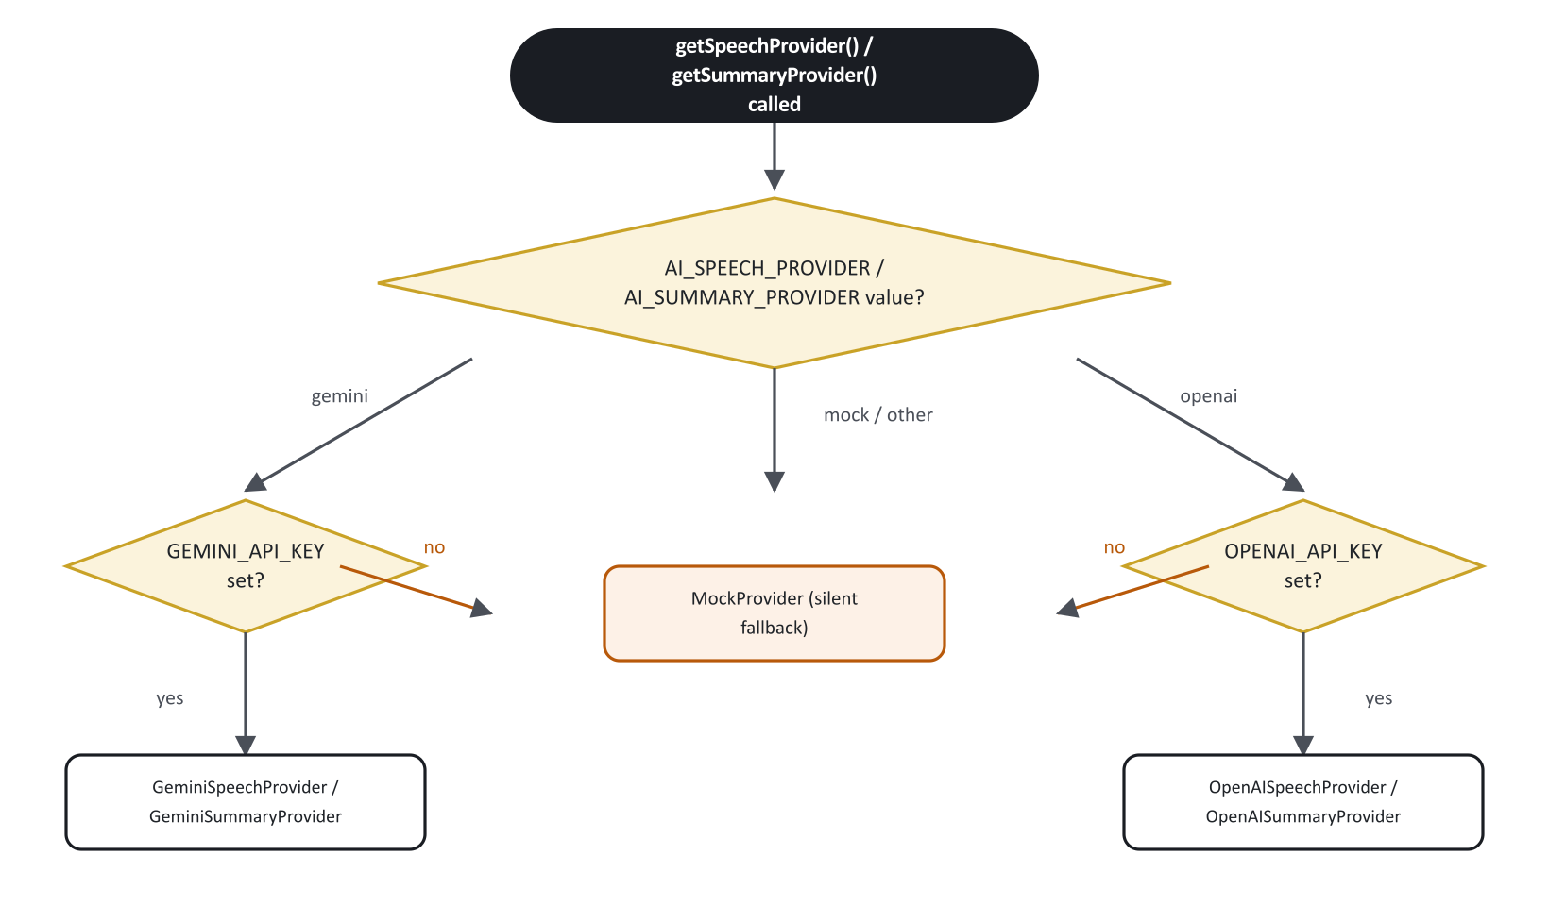
Figure 1. Provider selection logic (getSpeechProvider / getSummaryProvider).
A selected-but-unconfigured provider fails silently to mock — see 04 §4 — P1.

4.2 OpenAI transcription — exact calls
- Whisper — POST https://api.openai.com/v1/audio/transcriptions, multipart/form-data, model: 'whisper-1' (hardcoded — see T5), response_format: 'verbose_json', file field named audio.{ext} (extension derived from content type: webm, wav, mp3, m4a, ogg, or bin). Returns Whisper's native { text, language, segments: [{start, end, text}] } — no speaker information at all.
- If Whisper returned zero segments, the provider short-circuits and returns { fullText: text, language, segments: [] } without a second call.
- Otherwise, a speaker-classification pass — POST https://api.openai.com/v1/chat/completions, model: OPENAI_CHAT_MODEL (default gpt-4o-mini), response_format: { type: 'json_object' }, one user message listing every numbered Whisper segment and asking for {"speakers":[{"index", "speaker", "speakerLabel"}]}. The response is merged back onto the Whisper segments by index; anything unmatched or malformed defaults to speaker: 'unknown', speakerLabel: 'Unknown speaker'.
Net effect: 2 upstream HTTP calls per chunk with speech present (1 if the chunk was silent) — see P2 for the cost/latency implication.

4.3 OpenAI summarization — exact call
POST https://api.openai.com/v1/chat/completions, model: OPENAI_CHAT_MODEL, response_format: { type: 'json_object' }, single user-message prompt over the full merged transcript text, asking for {"executiveSummary", "keyLearningPoints": [], "importantQuestions": [], "actionItems": []}. Missing fields default to ''/[].

4.4 Gemini transcription — exact call
POST https://generativelanguage.googleapis.com/v1beta/models/{GEMINI_MODEL}:generateContent?key={GEMINI_API_KEY} (default model gemini-2.5-flash), generationConfig: { responseMimeType: 'application/json' }, request body containing one text prompt part plus one inlineData part ({ mimeType: contentType, data: base64(audioBuffer) }) — the raw audio bytes are sent inline in the request, not via the Gemini Files API (see P3). The prompt instructs the model to transcribe classroom audio, label each segment trainer/student/unknown, and return only minified JSON: {"language", "segments": [{"speaker","speakerLabel","text","startSec","endSec"}]}. fullText is derived by space-joining the returned segments' text.
Net effect: 1 upstream HTTP call per chunk, transcription and speaker labelling together.

4.5 Gemini summarization — exact call
Same endpoint/model, one prompt over the full merged transcript text, asking for minified JSON {"executiveSummary", "keyLearningPoints", "importantQuestions", "actionItems"}.

4.6 Structured JSON handling
Both providers rely on functions/src/ai/providers/json.ts:
- extractJson(text) — strips an optional Markdown code fence (` `json ... ` ) via regex before calling JSON.parse()`. See T2 for the lack of schema validation beyond this.
- toSpeakerRole(value) — returns value unchanged only if it is exactly 'trainer' or 'student', else coerces to 'unknown' — the sole defense against a model hallucinating an unexpected speaker label.

4.7 Environment variables (complete list)
Variable | Mechanism | Default | Required for
AI_SPEECH_PROVIDER | defineString | mock | Selecting gemini/openai for transcription
AI_SUMMARY_PROVIDER | defineString | mock | Selecting gemini/openai for summarization
GEMINI_API_KEY | defineSecret | none | Any Gemini usage
OPENAI_API_KEY | defineSecret | none | Any OpenAI usage
GEMINI_MODEL | defineString | gemini-2.5-flash | Used for both Gemini transcription and summarization
OPENAI_CHAT_MODEL | defineString | gpt-4o-mini | Used for both OpenAI's speaker-classification call and its summarization call (Whisper's model, whisper-1, is separate and hardcoded)
All are resolved via firebase-functions/params (.value() at runtime), not raw process.env. GEMINI_API_KEY/OPENAI_API_KEY must additionally be listed in the secrets: [...] array on processAiSessionJob's function definition or they will not be injected into the function's runtime regardless of being set at the project level.

5. Processing pipeline — API-level sequence for one chunk
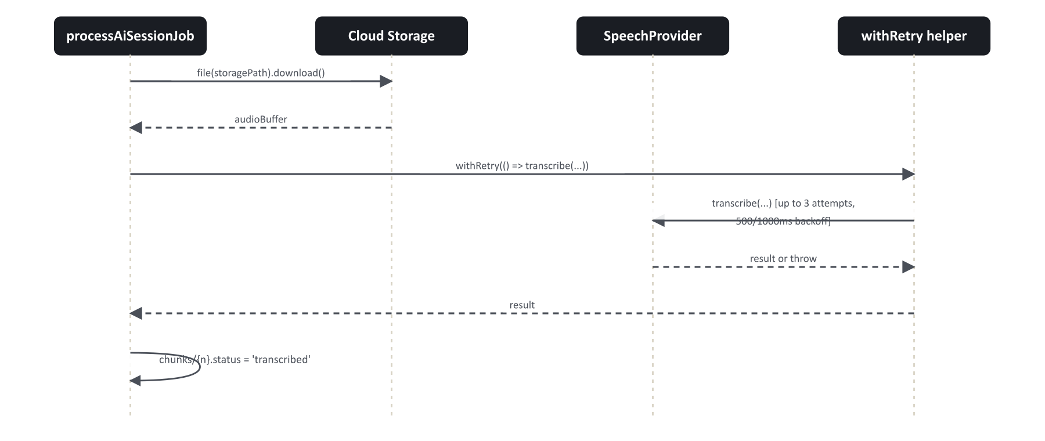
Figure 2. Per-chunk transcription sequence, including retry/backoff.
The same withRetry wrapper is used identically for the single summarize() call over the merged transcript. Exhausting all 3 attempts on any chunk or on summarization propagates as a thrown error that fails the entire job (stage: 'failed') — a single unrecoverable chunk failure stops the whole job rather than letting the rest of the session's chunks be skipped and marked complete, though chunks already transcribed before the failure remain so a retry resumes past them.

6. Processing stage matrix
Stage | Trigger to enter | Firestore writes made in this stage | Typical duration driver
queued | finalizeSessionRecording transaction creates the job | Session: status=processing. Job: created | Near-instant
transcribing | Transactional claim by the Cloud Function | Per chunk: chunks/{n}.status=transcribed + job.chunksCompleted++ | Sequential — proportional to chunk count × provider latency (R1)
merging | All pending chunks transcribed | aiTranscripts/{sessionId} created | Fast — in-memory concatenation
analyzing | Transcript written | (none until summarize resolves) | One upstream summarization call
saving | Summary generated | aiSummaries/{sessionId} created; session status=completed; aiIntelligenceSettings/config provider names merged; aiAnalytics/{today} incremented | Fast
completed | All writes done | job.stage=completed, progressPercent=100 | Terminal
failed | Any unhandled exception from transcribing onward | job.stage=failed + error; session status=failed; systemEvents doc; aiAnalytics/{today}.sessionsFailed++; Cloud Error Reporting | Terminal until manual retry

7. Role matrix (for quick API-consumer reference)
Action / Query | founder | system_admin | ops_manager | coordinator | trainer | others
createSession | ✅ | ✅ | ❌ | ❌ | ✅ | ❌
requestChunkUploadTicket / confirmChunkUpload / finalizeSessionRecording | ✅ (own only†) | ✅ (own only†) | ❌ | ❌ | ✅ (own only) | ❌
retryProcessingJob | ✅ (any) | ✅ (any) | ❌ | ❌ | ✅ (own only) | ❌
deleteSession | ✅ | ✅ | ❌ | ❌ | ❌ | ❌
updateAiSettings | ✅ | ✅ | ❌ | ❌ | ❌ | ❌
listSessions / getSessionDetail / listProcessingJobs / analytics / dashboard reads | ✅ | ✅ | ✅ | ✅ | ✅ | ❌
† Founder/system_admin could only create sessions they themselves own, since trainerUid is always the creator — there is no "create/record on behalf of another trainer" capability for any role.

8. Debugging checklist for API/provider issues
- Job stuck in `transcribing` with no progress for several minutes → check the Cloud Function's execution logs for the specific chunk index and provider error; the function has a hard 540-second (9-minute) total execution budget covering all chunks + merge + summarize (R2).
- Job `failed` with a message like `OpenAI transcription error 401: ...` → OPENAI_API_KEY secret is invalid/expired; the request never benefits from retry logic — it's an auth failure that fails all 3 attempts identically.
- Job `failed` with `Gemini API error 429: ...` → rate limiting; withRetry's linear backoff (500ms/1000ms) may not be sufficient for sustained high volume (P4).
- Session completes but transcript/summary text is the literal placeholder sentence → provider selected but its secret is missing (silent fallback to mock, P1) — not a bug, a configuration gap.
- `confirmChunkUpload` returns `ok: true, data: { status: 'failed' }` → this is not a thrown error; treat it as a business failure. The client's session-recorder.tsx handles this by counting it as a failed upload attempt and retrying the whole ticket→PUT→confirm cycle.
- `finalizeSessionRecording` rejects with "Chunk count does not match the reported recording length." → the client's reported totalChunks doesn't match what planSessionChunks(totalDurationSeconds) independently computes server-side — check for clock drift or a client bug in chunk counting, not a server misconfiguration.

